# ASSIGNMENT NO. 01(A)

Create a responsive web page which shows the ecommerce/college/exam admin dashboard with sidebar and statistics in cards using HTML, CSS and Bootstrap.

### PRE-REQUISITE:

* 1. Knowledge of HTML5.
  2. Knowledge of JavaScript.
  3. Knowledge of CSS.

### OBJECTIVE:

1. To study basic HTML and CSS commands.
2. To install Microsoft Visual Code.
3. Create a responsive web application.

### THEORY:

**What is HTML?**

HTML (Hyper Text Markup Language):-

Hyper Text Markup Language (HTML) is the predominant markup language for web pages.HTML elements are the basic building-blocks of web pages. HTML is written in the form of HTML elements consisting of tags, enclosed in angle brackets (like <html>), within the web page content. HTML tags most commonly come in pairs like <h1> and </h1>, although some tags, known as empty elements, are unpaired, for example <img>. The first tag in a pair is the start tag, the second tag is the end tag (they are also called opening tags and closing tags). In between these tags web designers can add text, tags, comments and other types of text-based content.

The purpose of a web browser is to read HTML documents and compose them into visible or audible web pages. The browser does not display the HTML tags, but uses the tags to interpret the content of the page.HTML elements form the building blocks of all websites. HTML allows images and objects to be embedded and can be used to create interactive forms. It provides a means to create structured documents by denoting structural semantics for text such as headings, paragraphs, lists, links, quotes and other items.

### Origins:

In 1980, physicist Tim Berners-Lee, who was a contractor at CERN, proposed and prototyped ENQUIRE, a system for CERN researchers to use

and share documents. In 1989, Berners-Lee wrote a memo proposing an Internet-based hypertext system. Berners-Lee specified HTML and wrote the browser and server software in the last part of 1990.

**<!DOCTYPE html>**

**<html>**

**<head>**

**Tells the document type The Root Element**

**Contains the header information**

**<title> Title of the Page</title>**

**</head>**

**<body>**

**Defines Title of the Page**

**Holds the content of the Page**

**Tags related to layout and formatting**

**</body>**

**</html>**

The first publicly available description of HTML was a document called "HTML Tags", first mentioned on the Internet by Berners-Lee in late 1991. It describes 20 elements comprising the initial, relatively simple design of HTML. Except for the hyperlink tag. Thirteen of these elements still exist in HTML 4.

### Structure of an HTML document:

**Basic HTML Tags:**

|  |  |  |
| --- | --- | --- |
| **Sr. No.** | **Tag Name** | **Description** |
| 1. | <html> </html> | Creates an HTML document |
| 2. | <head> </head> | Sets off the title and other information that isn’t displayed on the web page itself. |
| 3 | <body> </body> | Sets off Visible portion of the document |
| 4 | <title> </title> | Puts the name of document in the title bar. |
| 5. | <cite> </cite> | Creates a citation, usually italic. |

### HTML File Paths:

|  |  |  |
| --- | --- | --- |
| **Sr.**  **No.** | **Tag Name** | **Description** |
| 1. | < img src="picture.jpg"> | The "picture.jpg" file is located in the same folder as the current page |
| 2. | <img src="images/picture.jpg"> | The "picture.jpg" file is located in the images folder in the current folder. |

|  |  |  |
| --- | --- | --- |
| 3 | <img src="/images/picture.jpg"> | The "picture.jpg" file is located in the  images folder at the root of the current web. |

**Sample HTML Code:**

<!DOCTYPE html>

<html>

<head>

<title>Page Title</title>

</head>

<body>

<h1>My First Heading</h1>

</body>

</html>

### What is CSS?

CSS stands for Cascading Style Sheets. CSS is the language we use to style a Web page. CSS describes how HTML elements are to be displayed on screen, paper, or in other media. CSS saves a lot of work. It can control the layout of multiple web pages all at once. External style sheets are stored in CSS files. It is a style sheet language which is used to describe the look and

formatting additional

of a document written in markup language. It provides an feature to HTML. It is generally used with HTML to change the

style of web pages and user interfaces. It can also be used with any kind of XML documents including plain XML, SVG and XUL. CSS is used along with HTML and JavaScript in most websites to create user interfaces for web applications and user interfaces for many mobile applications.

### Sample CSS Code:

<!DOCTYPE html>

<html>

<head>

<style>

body {

}

h1 {

}

p {

}

</style>

background-color: lightblue; color: white;

text-align: center;

font-family: verdana; font-size: 20px;

</head>

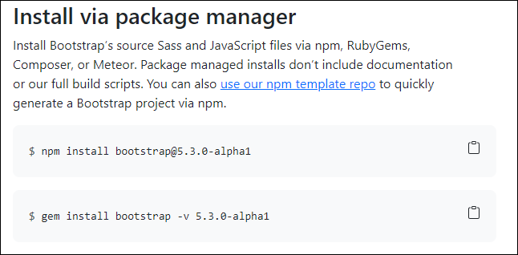

<body>

<h1>My First CSS Example</h1>

<p>This is a paragraph.</p>

</body>

</html>

### What is Bootstrap?

Bootstrap is the most popular CSS Framework for developing responsive and mobile-first websites. Bootstrap makes responsive web design a reality. It makes it possible for a web page or app to detect the visitor's screen size and orientation and automatically adapt the display accordingly.

### How to Use Bootstrap in your code:

Step 1: Open Goggle Chrome and search Bootstrap. Step 2: Open link <https://getbootstrap.com/>

Step 3: Install via Package Manager You can also [use our npm template](https://github.com/twbs/bootstrap-npm-starter) [repo](https://github.com/twbs/bootstrap-npm-starter) to quickly generate a Bootstrap project via npm.

Step 4: When you only need to include Bootstrap’s compiled CSS or JS, you can use [jsDelivr](https://www.jsdelivr.com/package/npm/bootstrap). See it in action with our simple [quick start](https://getbootstrap.com/docs/5.3/getting-started/introduction/#quick-start), or [browse the examples](https://getbootstrap.com/docs/5.3/examples/) to jumpstart your next project. You can also choose to include Popper and our JS [separately.](https://getbootstrap.com/docs/5.3/getting-started/introduction/#separate)

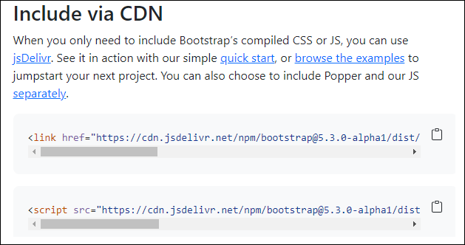

### CONCLUSION:

**OUTPUT:**

*(Attach Screenshots of y*